CH3052 Assignment-1

# Question-4: X-Ray Diffraction

## a) XRD simulation in Vesta

Chosen wavelengths (obtained from the CIF file)

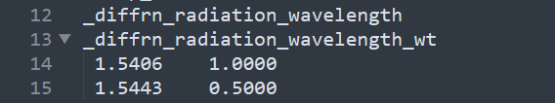

Figure 1: Extract of the CIF file displaying the wavelengths

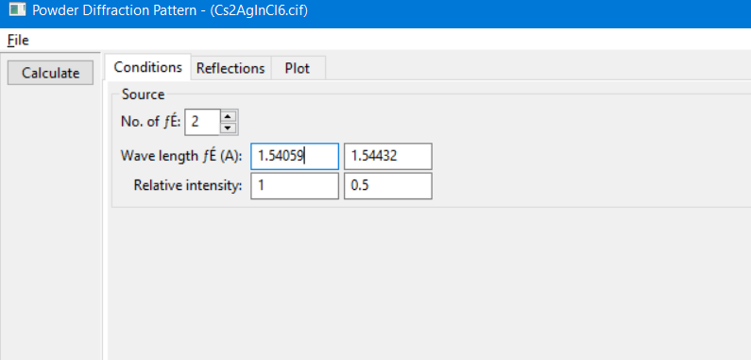

Figure 2: Applying the appropriate wavelengths in Vesta

XRD pattern was generated, and the generated data was exported to an excel file.

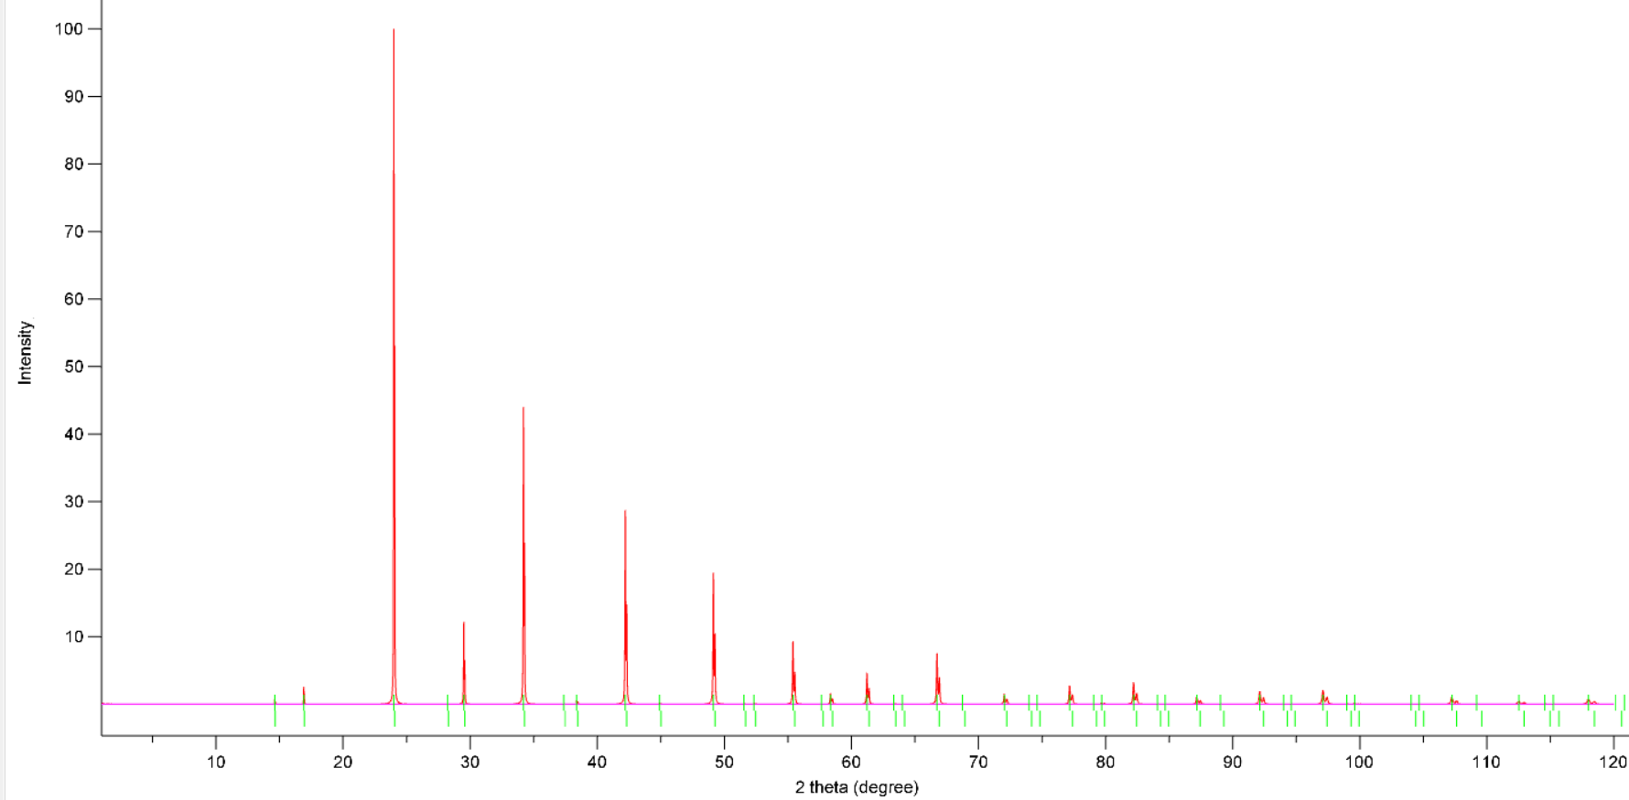

*Figure 3: XRD Pattern of Cs2AgInCl6­*

Now, from the excel file and with the help of the graph, I identified the peaks and noted down their 2θ values.

We can then get (from Bragg’s law): $d= \frac{λ}{2\sin{θ}}$

After getting d,

1. For cubic systems: $\frac{a^{2}}{d_{hkl}^{2}}= h^{2}+ k^{2}+l^{2}$
2. Allowed transitions for F type cubic lattices: h + k + l is even.

Using the above rules I found hkl corresponding to the peaks.



*Table 4.1: Table used to calculate hkl corresponding to the peaks* (at 2θ)

(I will share the excel file separately)



6,2,2

6,2,0

4,4,0

4,2,2

4,0,0

2,2,2

2,2,0

*Figure 4: XRD with peaks labelled.(upto 60 degrees)*

## b) Comparison with Experimental Data

Since we used the CIF file for Cs2AgInCl6, we compare it with that of the experimental data with x = 1. (No substitution)

Data was normalized in the following way:

* Keep the minimum value as zero
* Divide all values by the maximum intensity. This results in the maximum intensity becoming 1.

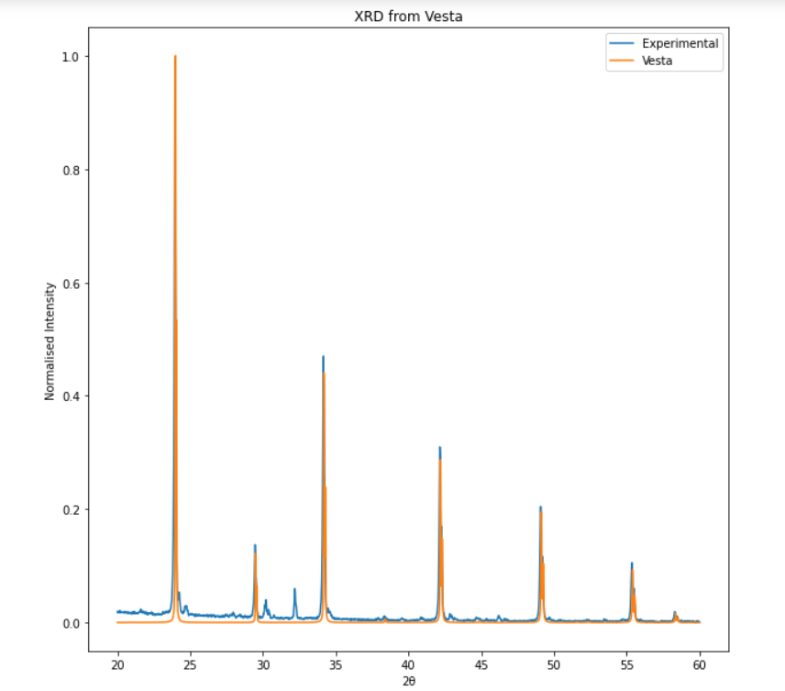

*Figure 5: Comparison of experimental and Vesta simulated XRD patterns.*

We find that the peaks are sufficiently close. Let us compute the ‘a’ value from the experimental data and check how close it is to the actual ‘a’.

* Recognise that the first peak has maximum intensity
* We know that the peak corresponds to (220) plane.
* Use Bragg’s law to obtain d. $d= \frac{λ}{2\sin{θ}}$
* Now use $\frac{a^{2}}{d_{hkl}^{2}}= h^{2}+ k^{2}+l^{2}$ to get ‘a’.

Using the above method, **aExp**t was found to be: **10.4964 Å** which is very close to the Vesta value of 10.4806 Å. Note that since the structure is cubic, we have a=b=c.

## c) a vs x plot

The above process to calculate ‘a’ was repeated utilizing the experimental data for different composition (‘x’). The results are tabulated below:

|  |  |  |  |  |  |  |
| --- | --- | --- | --- | --- | --- | --- |
| X | 0 | 0.2 | 0.4 | 0.6 | 0.8 | 1 |
| a (in Å) | 10.771 | 10.735 | 10.654 | 10.610 | 10.548 | 10.496 |

Note that since the structure is cubic, we have a=b=c.

The above data was used to plot a vs x.

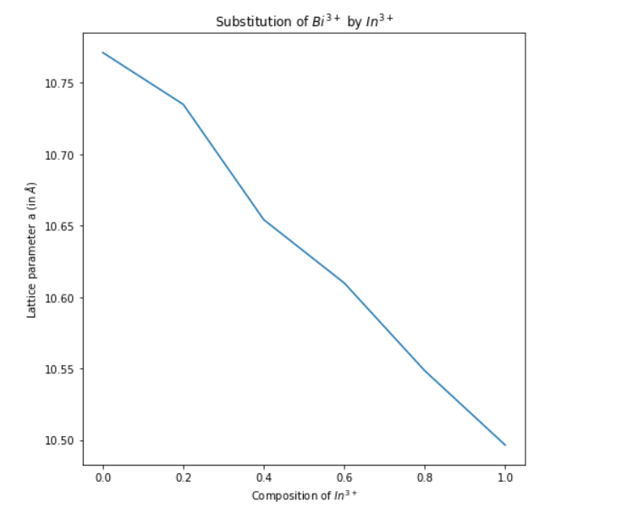

*Figure 6: a vs x plot for substitution of In3+ by Bi3+*

As we have seen in class, we again see a linear variation, this is expected.

Ionic radii from Shannon’s book:





We have a coordination number of 6 in this structure (for both In3*+* and Bi3+)

Ionic Radius of In­3+ = 0.92 Å

Ionic Radius of Bi3+ = 1.03 Å

Since Bi3+ is larger, if we substitute more of In3+ with Bi3+, the crystal size keeps getting larger!

This explains the linear increase in the graph. (**more substitution => larger the crystal size**)